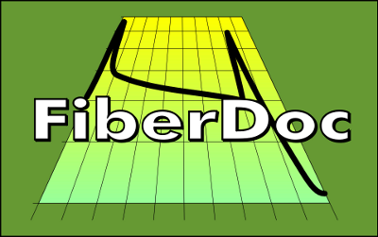
Your FiberDoc registration completed
Rostock, [DATE]
Dear FiberDoc user,
dear FiberDoc customer,
your FiberDoc registration is completed.
You can login and edit your FiberDoc account data at any time.
To open the login form, please click here.
FiberDoc Customer Service
You can contact our FiberDoc customer service as follows:
Phone: 0381 3677-9664-0
E-mail: service@fiberdoc.de
You can find always latest news and further information about our FiberDoc products on the FiberDoc homepage at www.fiberdoc.de
Kind regards,
Your FiberDoc - team
Sharedat Deutschland, Inhaber Claas Richter, Klosterhof 2, 18055 Rostock Deutschland,
Finanzamt Hansestadt Rostock 079/262/08297, USt-IdNr: DE227034266
Tel.: 0381 3677 9664-0 Fax: 0381 3677 9664-9 E-Mail: info@sharedat.de Web: www.sharedat.de
Diese E-Mail wurde mit fLARe® Business Cloud-Service erstellt - mehr unter http://flare.at-web.biz/

